ACCESS ROMOTE WEB SERVER BY END DEVICES

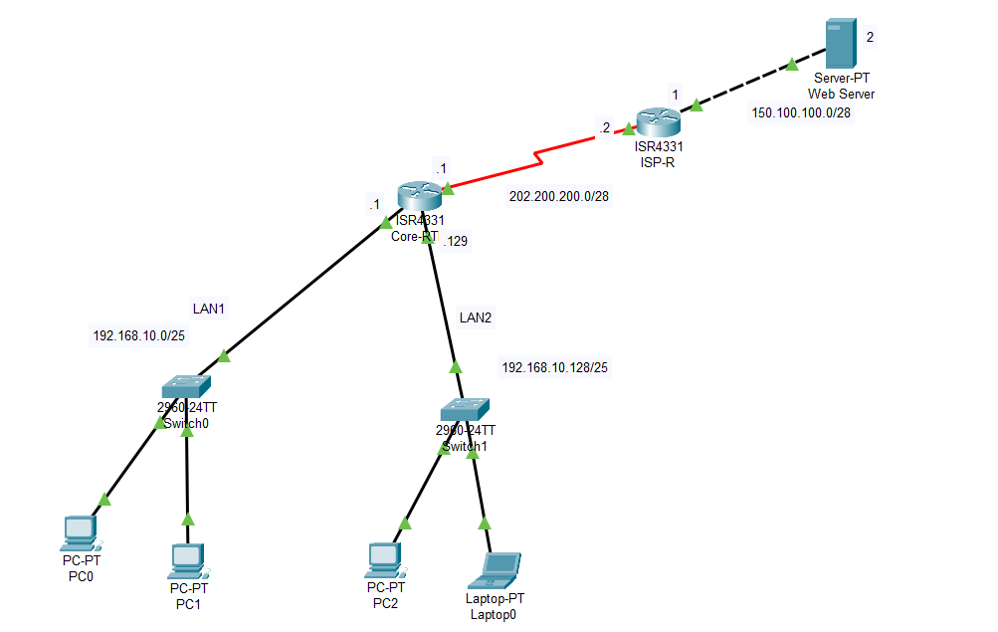

Introduction

This lab shows how to configure DHCP for two local networks (LAN1 and LAN2), implement dynamic NAT on the core router to translate private LAN addresses to a small pool of public addresses, configure static routing between the core and ISP routers, and verify that end devices can access a remote web server. The NAT pool used on the Core-RT will be 202.200.200.3 through 202.200.200.5 which will be used to dynamically translate hosts from both LANs.
- Configure DHCP pools for two /25 subnets.
- Configure a dynamic NAT pool on the Core router and apply NAT to LAN interfaces.
- Configure static routes so the ISP router can reach the internal LANs, and the Core router can reach the Internet (or remote server network).
- Verify connectivity and NAT operation (translation table, ping, HTTP).

Device / Interface | IP address | Subnet mask
Core-RT Gi0/0 (LAN1) | 192.168.10.1 | 255.255.255.128 (/25)
Core-RT Gi0/1 (LAN2) | 192.168.10.129 | 255.255.255.128 (/25)
Core-RT Gi0/2 (to ISP-R) | 202.200.200.1 | 255.255.255.240 (/28)
ISP-R Gi0/0 (to Core-RT) | 202.200.200.2 | 255.255.255.240 (/28)
Public NAT addresses (pool) | 202.200.200.3–202.200.200.5 | 255.255.255.240 (/28)
ISP-R Gi0/1 (to Web Server) | 150.100.100.1 | 255.255.255.240 (/28)
Web Server | 150.100.100.2 | 255.255.255.240 (/28)

2. Configure Core-RT interfaces, DHCP and NAT
In Core-RTR I will configure Dynamic NAT for the range of 202.200.200.3 to 202.200.200.5 to translate the LAN1 & LAN2 private ip to public ip to communicate between the internet.
Also configure the DHCP pool for LAN 1 and LAN2 in the Core-RTR as DHCP server and also configure the static route for the webserver to communicate with them.
Also configure the router interface ip.

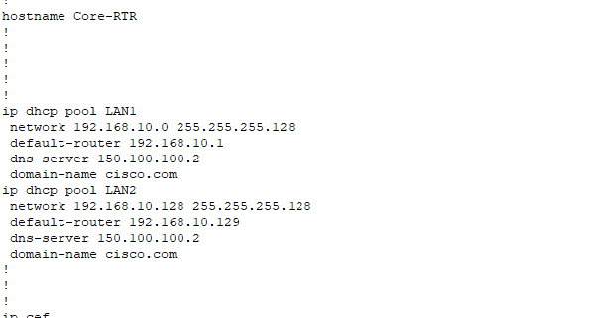
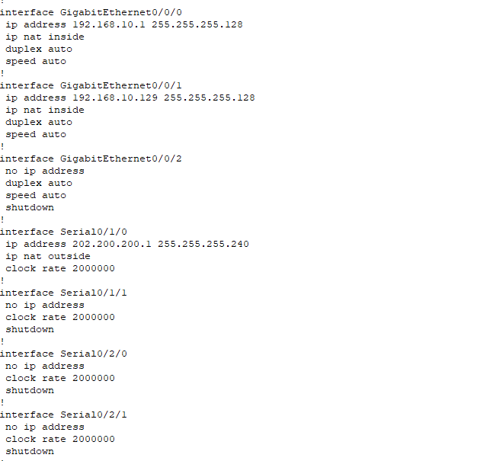
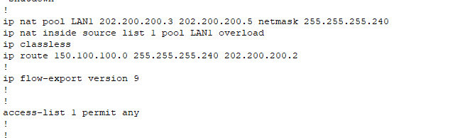

3. Configure ISP-R interfaces and static routes back to the LANs
In ISP-RTR I will configure the static NAT for LAN1 and LAN2 to communicate with the server and also configure the interface ip.

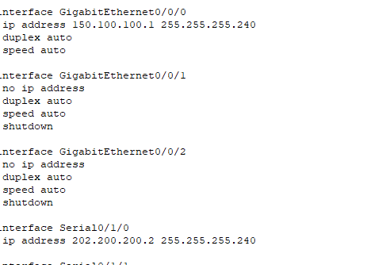
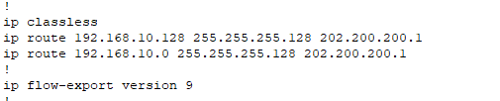

5. Configure the Web Server
Set the server IP configuration
- IP Address: 150.100.100.2
- Subnet Mask: 255.255.255.240
- Default Gateway: 150.100.100.1

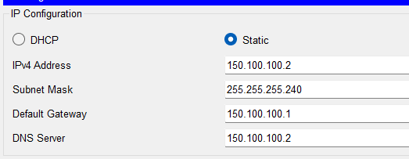

6. Configure PCs/Laptops to use DHCP
On each PC: Desktop → IP Configuration → DHCP. The PC should be assigned an IP from the corresponding DHCP pool with the correct default gateway.
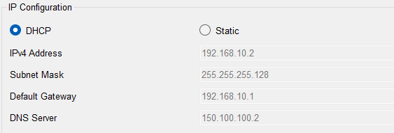
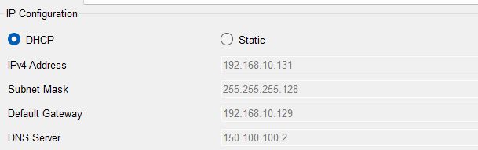

Verification & Testing
The web server is accessible by the web browser of the end host device it verifies that all the configurations are correctly configured.

